ISHERWOOD’S
£25 DEAL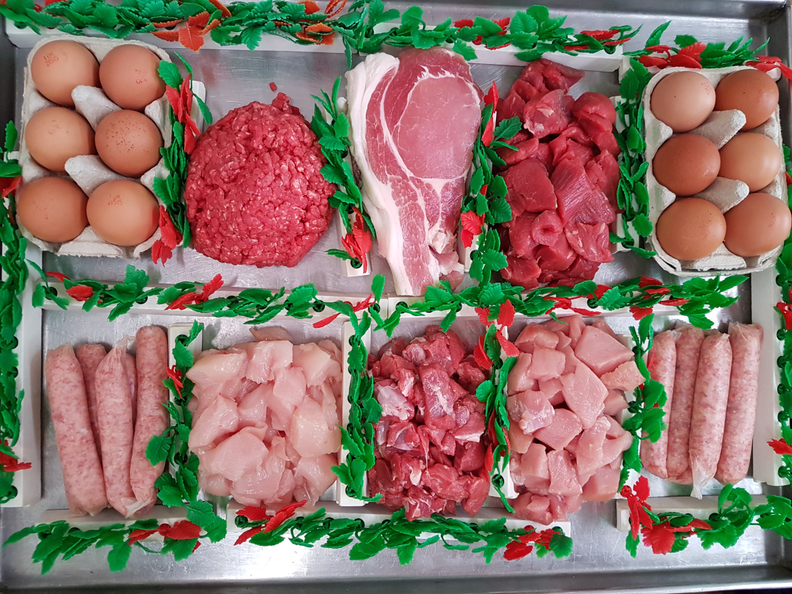

1lb MINCE
1lb STEW
1lb DICED LAMB
1lb SAUSAGE
1lb BACON
1lb DICED CHICKEN
1lb DICED PORK
12 LARGE EGGS

