ISHERWOOD’S
“MEAT LOVERS”
£25 BBQ PACK
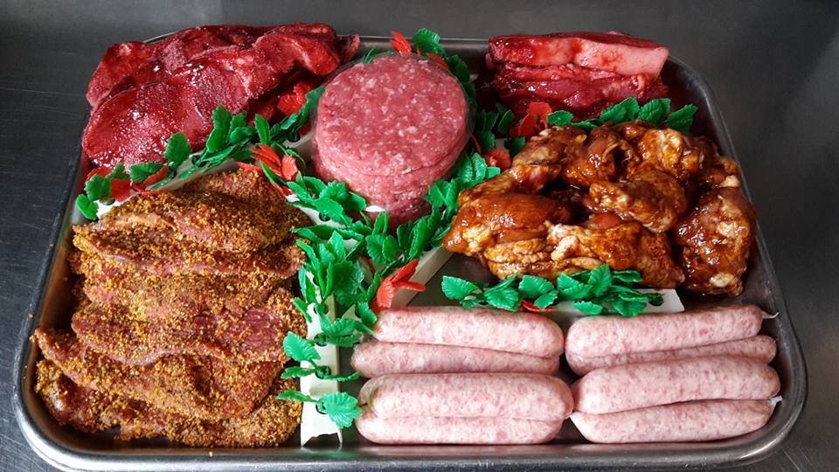

6 PEPPERED or PLAIN STEAKS
6 BEEF BURGERS
6 CHINESE BELLY PORK STRIPS
6 CHINESE BACON CHOPS
12 PORK SAUSAGES
12 BBQ CHICKEN WINGS

