ISHERWOOD’S
£20 BBQ PACK

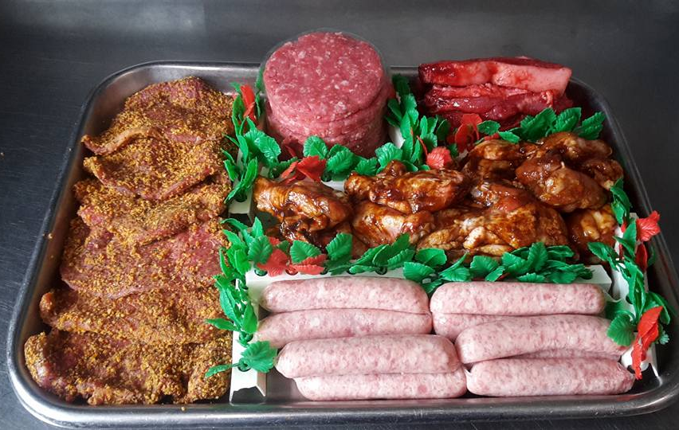

6 PEPPERED or PLAIN STEAKS
6 BEEF BURGERS
6 CHINESE BELLY PORK STRIPS
12 PORK SAUSAGES
12 BBQ CHICKEN WINGS

